Planning Hair rendering thesis
Jeffrey Lemein

1. | Setting up the project  - Set up build system by using cmake, and set up proper directory structure.  - Keep all builds and renderings out-of-source, so that source files and directories never get cluttered.  - Prepare scripts to:  - simplify hair models by Cem Yuksel (for faster rendering)  - A render script, that preprocesses PBRT scene files to set render properties.  - Render frame script should render a single frame  - All settings must be able to be specified via this script (using a property file with key value pairs, or on command line by key=value).  - Each rendering of a frame should result in a new directory in the output directory together with all data to re-render on the fly when needed. | 32 hours
2. | Use PBRT to render example scene using path tracing (reference material)  http://www.pbrt.org  - Set up PBRT  - Find/Create a realistic example scene using realistic lighting  - buy additional memory to have at least 16GB RAM, because:  - Curly hair model is ~750 MB, containing more than 3 million hair strands.  - I asked forum and it is likely that I need more RAM.  - Be able to render a path-traced image (that serves as the reference material for my final renderings). See below what is included in PBRT. Cem Yuksel has more hair models on his website.  - http://www.cemyuksel.com/research/hairmodels/  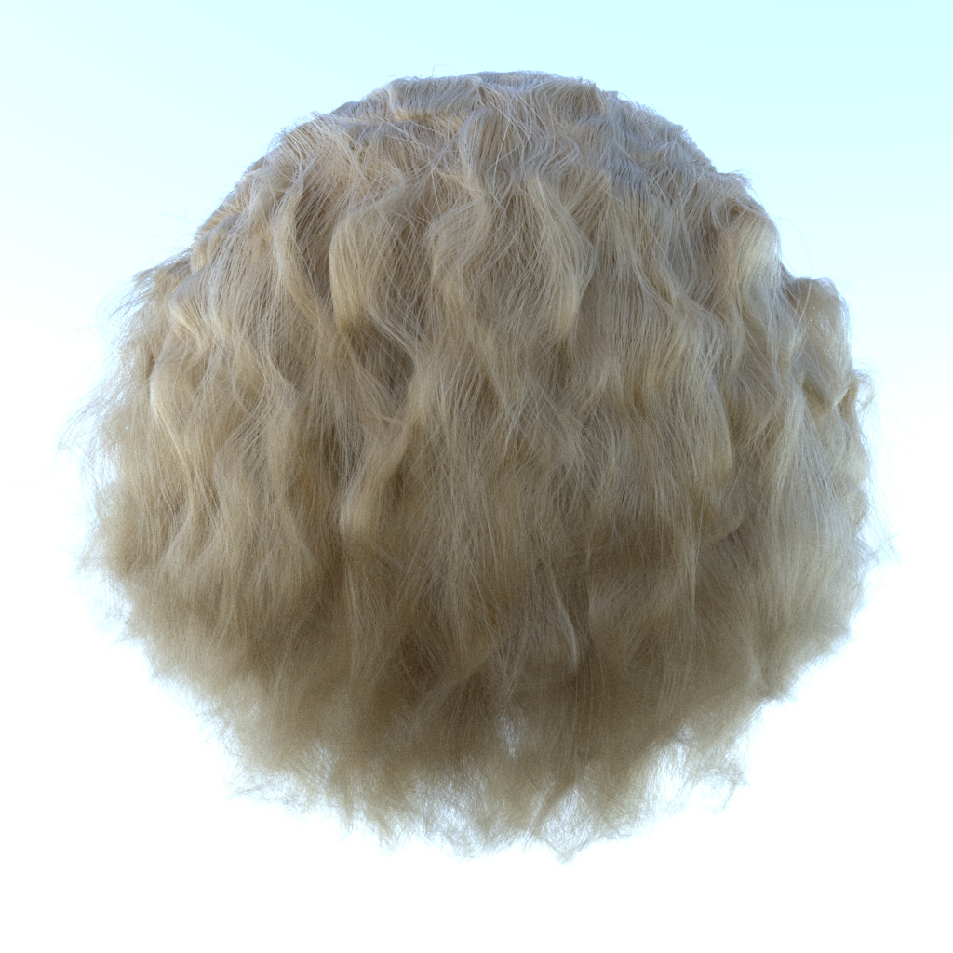  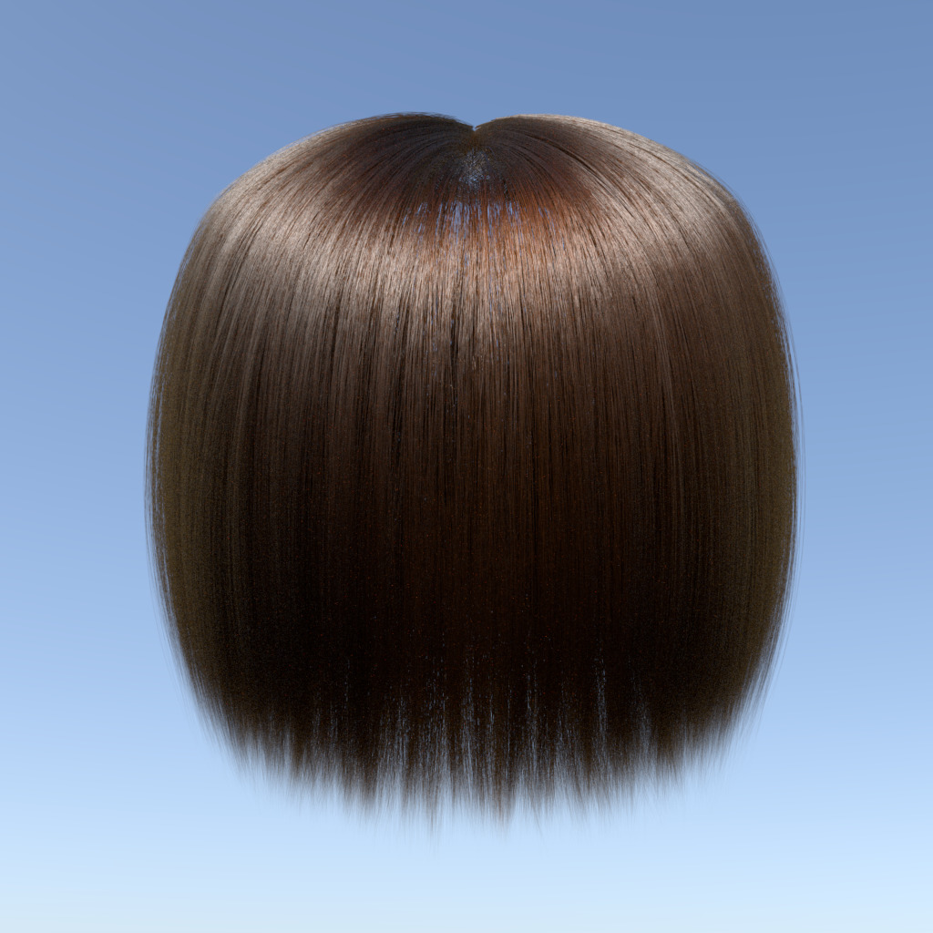 | 32 hours
3. | Use OpenVDB to create a voxel density grid  http://www.openvdb.org/  - Needed to store densities of the hair per voxel  - Should be run once per hair model and can be reused for different renderings.  - Used to quikly find the density when a ray is propagated through the hair volume. | 40 hours
4. | Migrate marschner/dual scattering shader code to PBRT  - Should be relatively painless, both are written in C++.  - The only difference is that before it was linked as plugin to Pixar’s Renderman and now it should be part of PBRT scene. | 32 hours
5. | Adjust code to create Marschner/Dual Scattering lookup table  - Lookup data contains precomputed values for Marschner and Dual-Scattering algorithms.  - Code is already there, but there were flaws with it | 24 hours
6. | Render scattering responses to file  - use visualization tool to plot results,  - investigate visualization tools (probably Matlab is used)  - a file with properties must also be passed as argument | 32 hours
7. | Analyze response data  - fit mathematical formula to scattering distribution  - invert scattering distribution formula  - Find out how to use discrete approach to finding the inverted function | 80 hours
8. | Code sampling strategy in PBRT | 60 hours
9. | Render samples using my optimized implementation (with importance sampling)  - Render same scenes as in step 2. | 16 hours
10. | Evaluate performance of algorithm  - measure rendering time and quality (noise)  - compare versus dual scattering papers  - compare versus path tracing result  → compare to path noise example using 1024 samples and 32 integration steps. | 40 hours
11. | Add everything in thesis | 40 hours
Total
428 hours (11 weeks full time)

